**E**veryone deserves to live in a safe and healthy home. It’s important for people of all ages, including children, adults, and seniors. It is estimated that most family members spend 70 percent or more of their time inside their home. Millions of these homes, however, have hidden hazards that can impact the health of the occupants and visitors.

Introduction

*To Safe and Healthy Homes*

Scientific research has revealed that many homes contain one or more hazards that adversely affect human health. According to a 2013 interagency government task force and the National Center for Healthy Housing, these housing-related hazards pose a wide range of risks, including:

* [Mold](http://www.nchh.org/LinkClick.aspx?link=464&tabid=463) and pests can specifically cause and contribute to asthma, allergies, and other respiratory illnesses. Poor housing conditions, in general, play a significant role in the respiratory health of vulnerable family members. The Centers for Disease Control and Prevention estimates that 1 in 12 adults and 1 in 10 children in the U.S. suffer from asthma.
* Toxins such as [lead](http://www.nchh.org/LinkClick.aspx?link=472&tabid=463), [asbestos](http://www.nchh.org/LinkClick.aspx?link=465&tabid=463), and household chemicals are detrimental to human health in a variety of ways. Lead poisoning in children causes reduced IQ and attention span, hyperactivity, impaired growth, reading and learning disabilities, hearing loss. The U.S. Department of Housing and Urban Development estimates that over 24 million homes have lead paint somewhere in the structure and there are approximately 500,000 children in the U.S. with elevated blood lead levels.
* Invisible poisonous gases such as [carbon monoxide](http://www.nchh.org/LinkClick.aspx?link=467&tabid=463) and [radon](http://www.nchh.org/LinkClick.aspx?link=474&tabid=463) also pose serious threats to family health. Carbon monoxide poisoning results in more than 200 accidental deaths a year and, at much lower levels, causes flu-like symptoms, which often go undiagnosed. Radon can increase the risk of cancer, which is the second leading cause of death among adults and children in the U.S., responsible for approximately 21,000 lung cancer deaths per year.
* Falls are the leading cause of deadly and non-deadly accidental injuries for people aged 65 and older. Older adults are more likely to be victims of falls, and the resulting injuries can affect their ability to lead an active life.

**

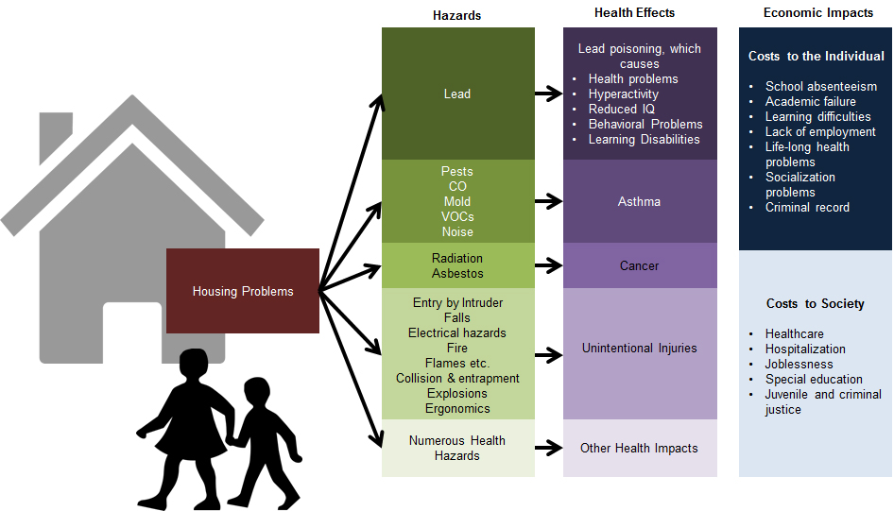Anyone can suffer from these housing-related illnesses and injuries, however, certain groups such as children, the elderly, or individuals with chronic illness are more at risk. Besides predictable increases in illness and injury, an unhealthy home can also be a financial burden to an individual or family as shown by this diagram:

**6.8 million homes**  
*have radon exposures above the current EPA action level.*

**Lung cancer***from radon exposure causes***21,000 deaths** *in the U.S. each year.*

**18,000 deaths***related to injuries occur annually in U.S. homes.*

**12 million nonfatal injuries**

*occur annually in U.S. homes.*

**24 million homes***have significant lead-based paint hazards, as measured by dust wipes.*

**Lead poisoning**

*effects*

**535,000***U.S. children ages 1-5*

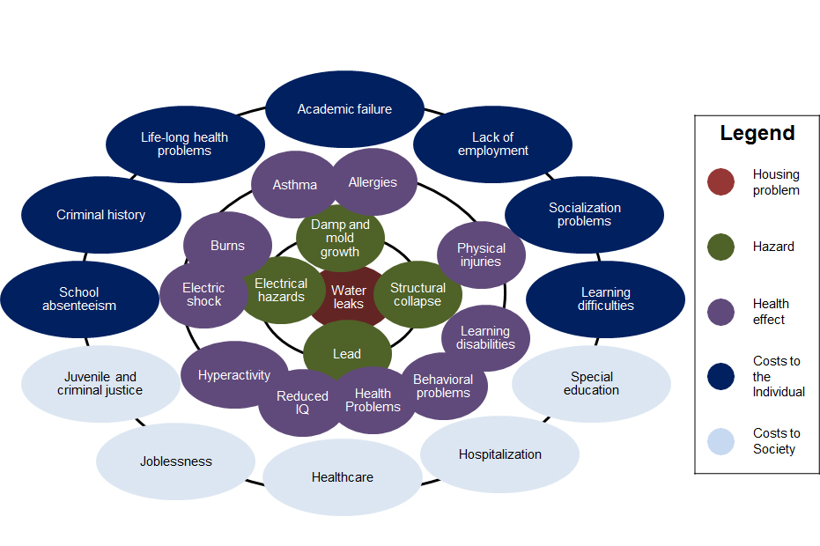Here is an example of how a single unhealthy housing problem can lead to multiple health effects and economic impacts: It is like a “pebble in a pond”: the impacts of one hazard can contribute to the many facets of the home, health, and community impacts.

This guide is a useful tool for stakeholders who serve all types of families from all zip codes. A healthy home can mean something different to each family but it can make a difference to every family. A stakeholder can be any person or group of persons that work and serve the local populations of all ages to assist them in maintaining or improving their safety and wellbeing. Examples include:

* Medical offices and health care professionals
* School nurses and teachers
* Church leaders and agencies
* Public health or housing departments
* Agencies on youth and aging
* Community college, university and state outreach and extension
* Public assistance programs
* Not-for-profit organizations
* Home and professional daycare businesses

The best approach to ensuring healthy homes for families is to encourage and facilitate a cleaning and maintenance plan, for each individual family that a health provider serves, based on a holistic home assessment related to the family’s vulnerabilities. A healthy homes assessment is a great first step to help prevent diseases and injuries that result from housing-related hazards and deficiencies. Stakeholders can use this guide to educate, assess, advocate, train, and set standards and policy on healthy homes for their offices and organizations.

*This guide is a companion to a consumer guide on safe and healthy homes for families, homeowners, or renters. For more information on the consumer guide, please visit* ***www.hud.gov/healthyhomes****.*